Chapter 14 - Motion, Forces, and Newton’s Laws Lesson 3: Newton’s Laws
Newton’s Laws
Recall that forces are measured in a unit called a newton (N).
This unit is named after English scientist Isaac Newton, who studied the motion of objects.
Newton summarized his findings in three laws of motion.
Newton’s First Law
- The tendency of an object to resist a change in motion is called inertia.
- Inertia acts to keep you at rest when the ride starts moving. It also keeps you moving in a straight line when the ride stops or changes direction.
- Newton’s first law of motion states that if the net force acting on an object is zero, the motion of the object does not change. In other words, an object remains at rest or in constant motion unless an outside, unbalanced force acts on it.
- Newton’s first law of motion is sometimes called the law of inertia.
Effects of Balanced Forces
Objects at Rest
- At the top of the ride, the force of the cable pulling upward on the car is equal to the force of gravity pulling downward on the car.
- Gravity and the cables pull on the car equally, but in opposite directions. As a result, the forces are balanced. The car is at rest.
- As long as the forces remain balanced, the car remains at rest.
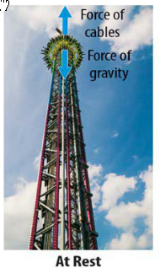

Objects in Motion
- To lift the car to the top of the ride, the cable pulls upward.
- After a short acceleration, the car moves upward at a constant speed.
- The force of the cable pulling upward is the same size as the force of gravity pulling downward.
- With the forces once again balanced, the car rises to the top of the ride at a constant velocity.
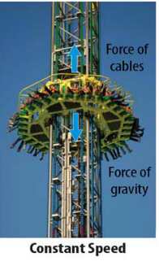
- Newton’s first law describes the car’s motion when the forces applied to it are balanced
- Balanced forces act on the car only when it is at rest or moving with a constant velocity.
Effects of Unbalanced Forces
According to Newton’s first law of motion, the motion of an object changes only when a net force acts on it.
Unbalanced forces cause a bungee jumper to speed up during part of the ride and slow down during another part of the ride.
Speeding Up
After the ride attendant releases you, the upward force of the bungee cord is greater than the downward force of gravity.
The forces are unbalanced.
The net force acting on you is upward, and you accelerate upward. This is positive acceleration because you are speeding up.

Slowing Down
As you approach the top of your bungee ride, the cords become slack. The upward force of the cords becomes less than the downward force of gravity.
Even though you still are moving upward because of inertia, the net force is now due to the downward force of gravity.
You slow down, or decelerate (negative acceleration)
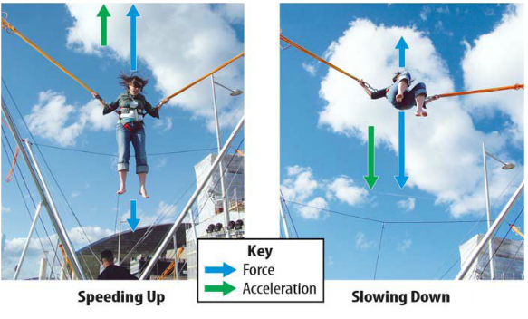
Changing Direction
- Your next stop is a swing ride. You sit in a chair attached by cables to a canopy on a center post. The post and canopy turn in a circle, propelling your chair outward on its cables.
- When the ride starts to turn, the force of the cables pulls your chair toward the center of the ride. The force of gravity acts downward.
- Because these forces don’t act in opposite directions, the unbalanced force constantly changes your direction.
- The unbalanced force of the cable pulling toward the center makes you accelerate in a circular direction.
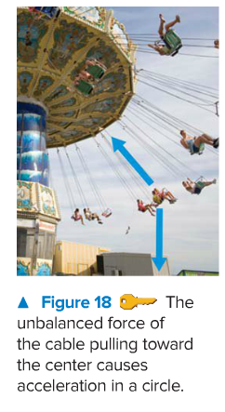
Newton’s Second Law of Motion
- Newton described the relationship between an object’s acceleration (change in velocity) and the net force exerted on the object.
- Newton’s second law of motion states that the acceleration of an object is equal to the net force exerted on the object divided by the object’s mass.
- The direction of acceleration is the same as the direction of the net force.
The following formula expresses Newton’s second law of motion.
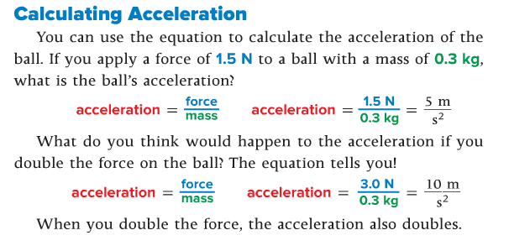
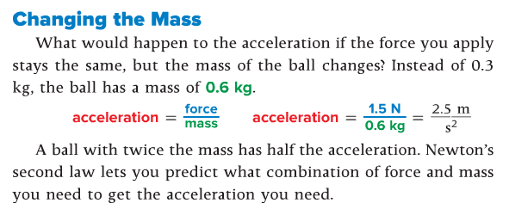

Newton’s Third Law
Newton’s third law of motion says that when one object applies a force on a second object, the second object applies a force of the same size, but in the opposite direction, on the first object.
According to Newton’s third law, the bumper cars apply forces to each other that are equal but are in opposite directions.
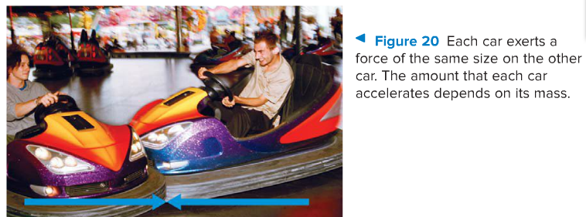

Action and Reaction Forces
When two objects apply forces on each other, one force is the action force, and the other is the reaction force.
- The bumper car that accelerates into the other car applies the action force.
- The car that takes the hit applies the reaction force.
Force Pairs
As you walk around the amusement park, your shoes push against the ground. If the ground did not push back with equal force, gravity would pull you down into the ground!
When two objects apply forces on each other, the two forces are a force pair.

Opposite Forces
The opposite forces of the bumper cars hitting each other are a force pair.
Force pairs are not the same as balanced forces. Balanced forces combine or cancel each other out because they act on the same object. Each force in a force pair acts on a different object.
When a soccer player hits the ball with her head, her head applies a force on the ball. The ball applies an equal but opposite force on her head.
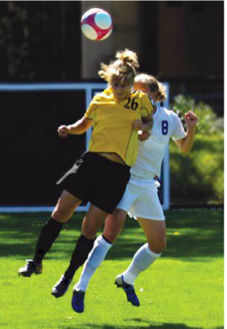
Newton’s laws work together.
- Newton’s first law explains that a force is needed to change an object’s motion.
- Newton’s third law describes the action-reaction forces.
- Newton’s second law explains why the effect of the force is greater on the ball. The mass of the ball is much less than the player’s mass. Therefore, a force of the same size produces a much greater acceleration in the ball.
